**New User Registration**

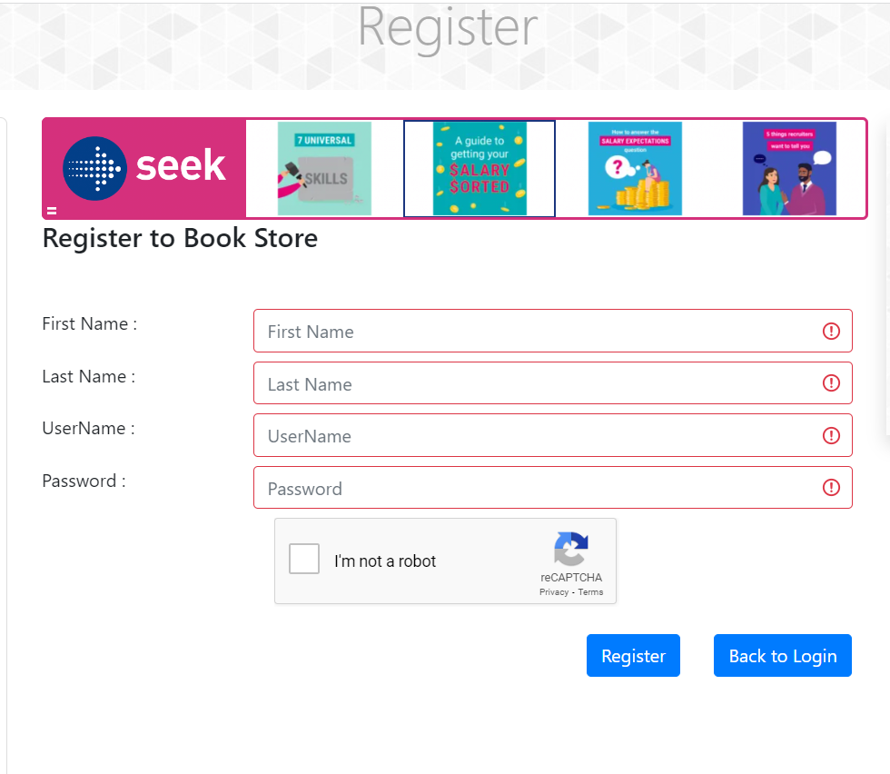

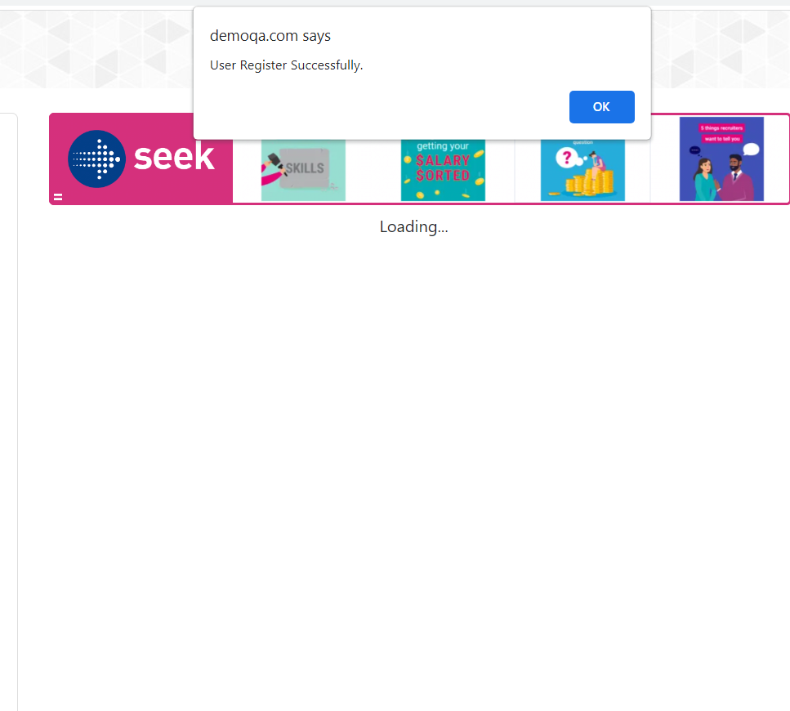

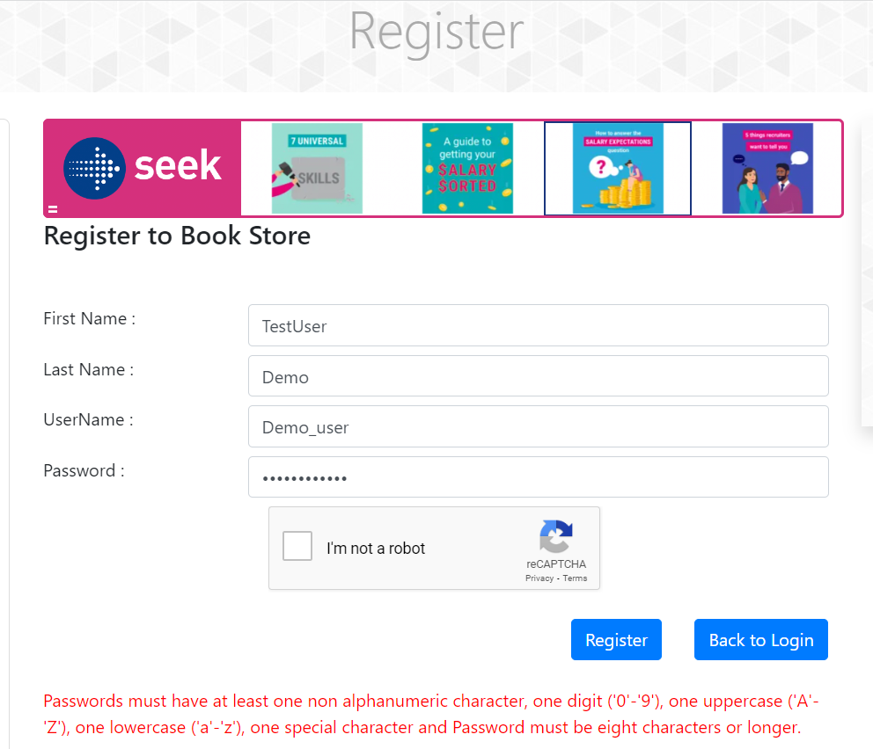

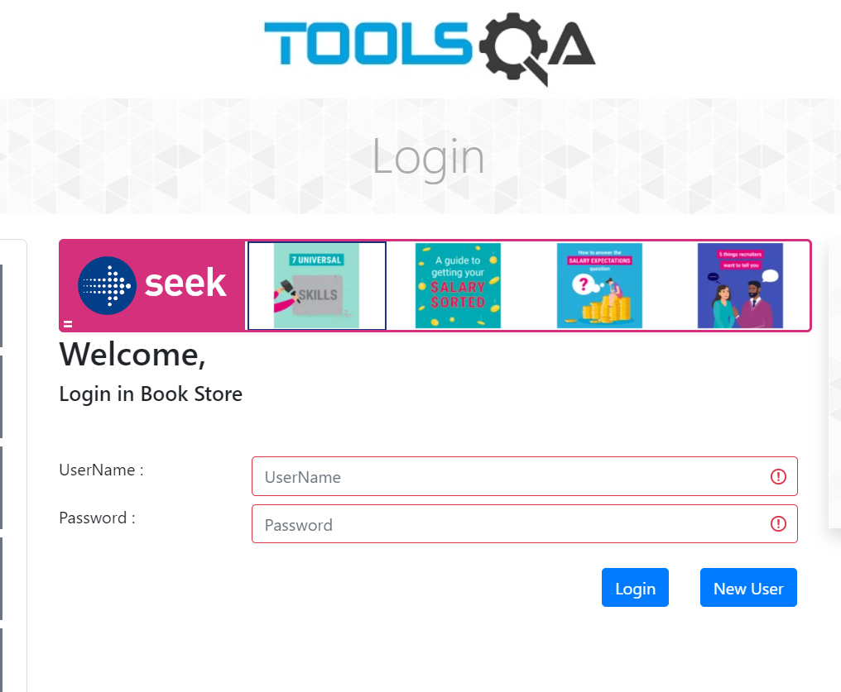

**Profile**

Add Book:

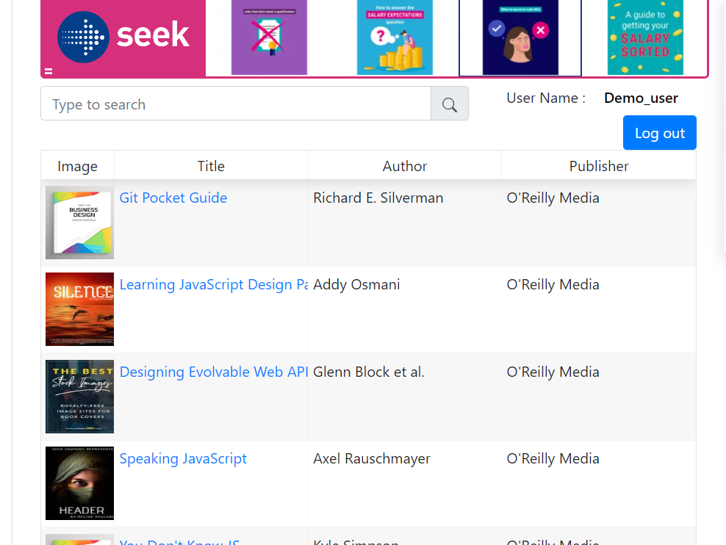

Delete Book:

Pagination:

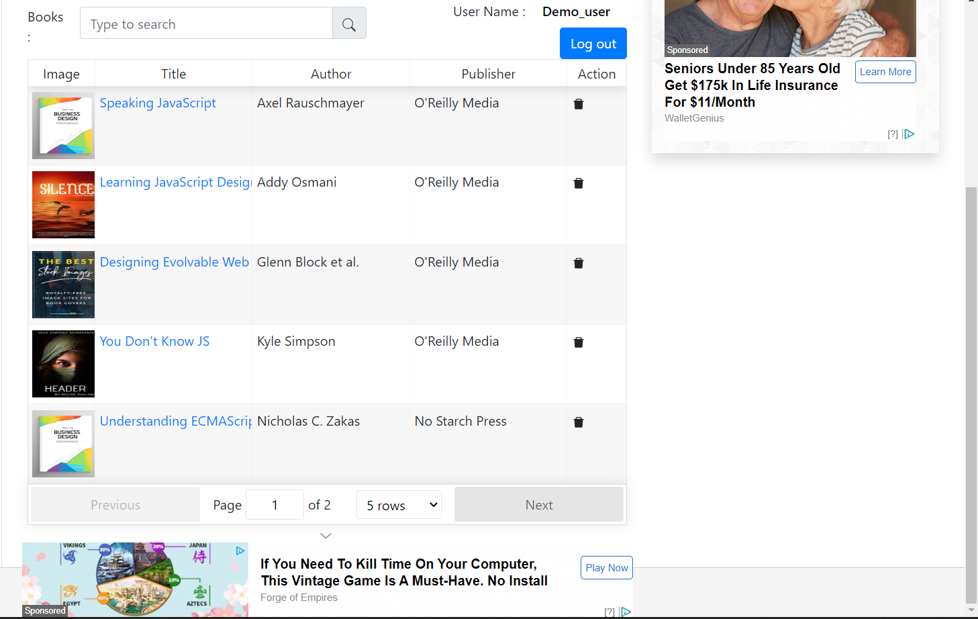

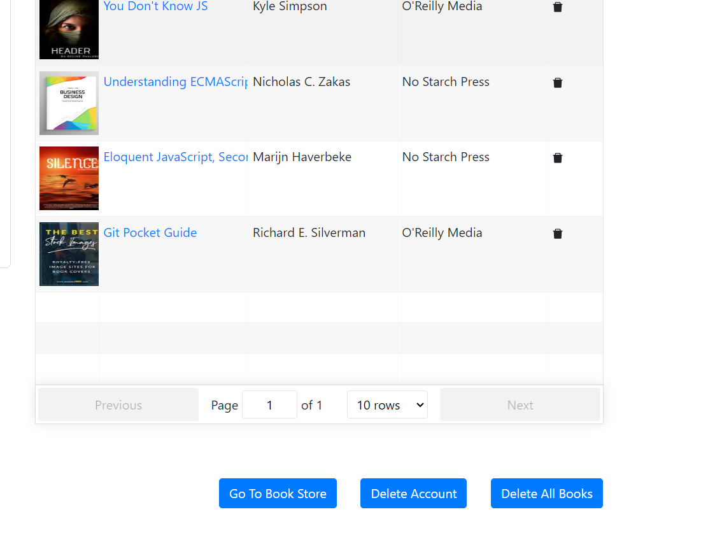

Sorting:

Search:

Delete All Books:

Delete Account:

